Paul confronts idolatry

[Text: Acts 17:16]

It was now four hundred years after the golden age of Greece, and Athens was still a centre of art, beauty, culture, and knowledge though it was in a period of decline when Paul visited it.
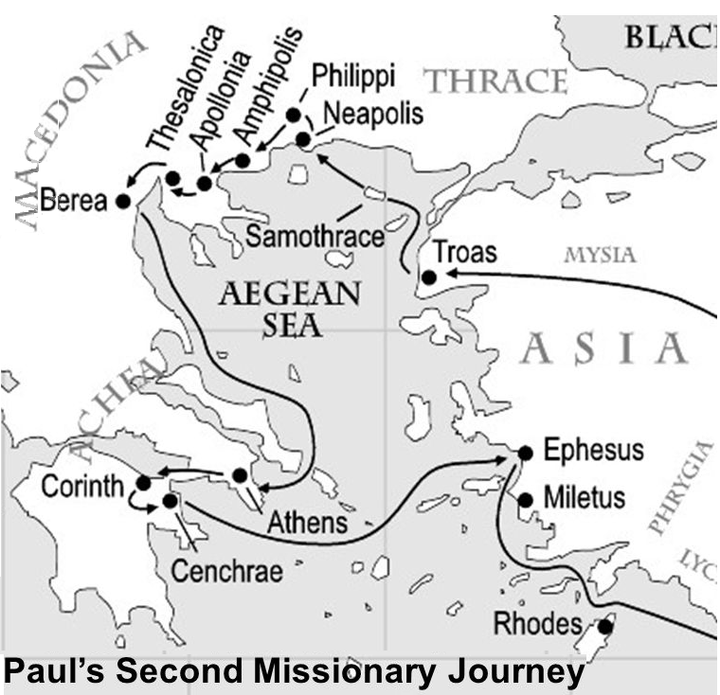

The city was swamped by idols. One of the ancient writers tells us that at this time there were 30,000 gods in Athens. Peterronius, one of the ancient historians, said that it was easier to find a god there than a man!
Greek verb paroxyno (distressed, irritated, stirred up and provoked, deep mixture of both anger and sorrow). It is same word used to describe God’s reaction to the Israelites who made the golden calf at Mount Sinai (Deut 9:7,18,22), and when later they were guilty of gross idolatry and immorality is relation to Baal of Peor.(Ps 106:28-29).
Scripture sometimes calls this emotion ‘jealousy’. When is jealousy sinful and when is it righteous?
So Paul was ‘provoked’ by idolatry for the honour and glory of His name. In other words, Paul tended to look at life through a Biblical “filter”.

What do we know about idolatory?
An idol is anything that replaces the one, true God, and idolatry is one where the honour, reverence and devotion due to God is given to some person or thing.
In the Bible there is no more serious charge than that of idolatry.
God is unique and is not capable of being represented. Deuteronomy 4:15-19
The first commandment is to have no gods before God (Exod. 20:3 ; Deut 5:7). In addition, the making of any images (Exod. 20:23) or even the mention of the names of gods (Exod. 23:13) was forbidden. Invoking the name of a god was an acknowledgment of its existence.
All the references to God’s jealousy in the Pentateuch have to do with idol-worship. Ex. 20:5. Not one of the other commandments contains such a solemn declaration of God’s character and of His judgment against the disobedient.
From the beginning, the threat of idolatry was in the midst of Israel. The forefathers were idolaters and, while Abraham was called out of a polytheistic background (Joshua 24:2 ), some persons brought their gods with them (Gen 35:2-4).
The history of Israel under their judges and kings is a record of repeated falling into idolatry. The portrayal of the kings in 1 and 2 Kings shows that they are assessed as either good or bad purely on the question of whether they destroyed or introduced idols.
Following the exile and subsequent struggles during the inter testament times, the Jews no longer fell prey to physical idolatry.
As the gospel message spread, it encountered various forms of idolatry in the pagan world as attested in Acts, especially Paul's encounter here at Athens (17:16-31) and Ephesus (19:23-34).
It is not necessary, for a man to formally deny God and Christ, in order to be an idolater. Professed reverence for the God of the Bible and actual idolatry, are perfectly compatible. (Exodus 32:4, 5). (1 Kings 12:28). In both instances, we should observe, the idol was not set up as a rival to God, but under the pretense of being a help—a steppingstone to His service.
Man wants a God at his own level. He wants to make a God in his image. He is always ready to devise visible helps and stepping stones to approach God and ultimately gives these inventions the honor due to God. Idolatry is a natural product of man’s heart.

What lessons do we learn from Athens?
Athens contained the most learned, civilized, philosophical, highly educated, artistic, intellectual population on the face of the earth. It was the city of wise men like Socrates, Aristotle and Plato. Yet this city was wholly given to idolatry.
Lesson#1 The absolute need of a divine revelation
Lesson#2 Intelligence and education is no protection against utter darkness in faith
Socrates or Plato might have talked eloquently on many subjects, but they could have never answered the jailor's question, "What must I do to be saved?" (Act. 16:30). He could never have said in his last hour, "O death, where is your sting? O grave, where is your victory?"
"Is not reason alone sufficient?" "Is the Bible really needful to make men wise unto salvation?" The entrance of your (God’s) word gives light. (Psalm 119:130). If we are concerned for souls, we should pray for them and find ways to expose them to God’s word.

