Paul preaching to a diverse audience in Athens

[Text: Acts 17:16-33]
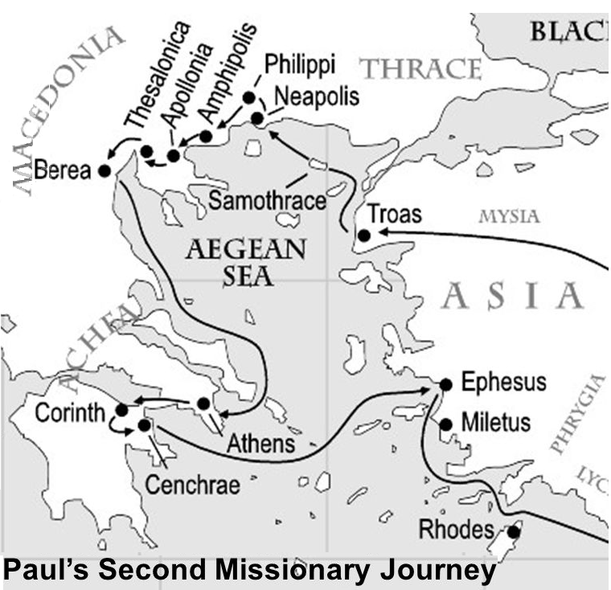
Athens was the intellectual capital of the Greco-Roman world. It was now four hundred years after the golden age of Greece.

Paul preaches in the synagogue and marketplace
Acts 17:16-21
In the synagogue, he debated with the Jews and God-fearing gentiles. But the marketplace was the public space --- for ideas, philosophies, business, art and EVERYTHING. And EVERYONE was there. There were only three such market places in the Greco-Roman world— Rome, Alexandria and Athens.
The Epicureans (followers of Epicurus) and the Stoics (followers of Zeno), who were the dominant philosophers in Greek culture, were among those in the marketplace. The Epicureans and Stoic philosophers though they differed radically in their beliefs were united in their opposition against Paul.
Some said he was a babbler (spermologos) not having an original idea in their heads, plagiarized from others, picking up scraps of knowledge here and there.
Others said ‘He seems to be advocating foreign gods.’

A model of speaking outside the community
Acts 17:22-23
Paul could speak to audiences in the synagogue (comparable to church), marketplace (comparable to streetcorner) Areopagus (comparable to university). Unlike Paul one person may not be given the gift of speaking to different audiences.
Paul begins his talk about an unknown god something they know about and then moves on to the unfamiliar.
Now what is this altar to an unknown god?

Paul shows the audience who the true God is
Acts 17:24-31
Luke’s record of sermons are always summary-outlines. This talk by Paul follows this outline:
1. God is the creator of the universe vs 24
2. God is the Sustainer of life vs 25
3. God is the Ruler of all nations vs 26-27
4. God is the Father of human beings vs 28-29
5. God is the Judge of the world vs 30-31
a. The judgement will be universal
b. The judgement will be righteous
c. The judgement will be definite

The crowd’s reaction to the preaching
Acts 17:32-33

