Paul’s mission in Corinth

[Text: Acts 18:1-17]
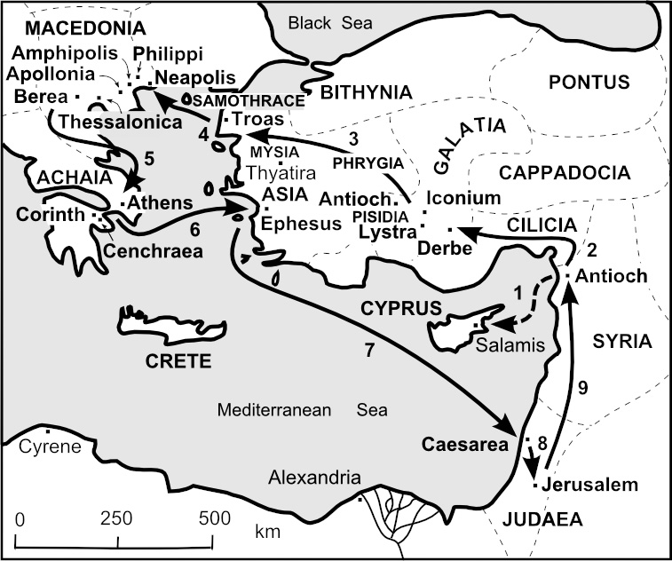

Acts 18:1
If Athens was the intellectual centre of the empire, Corinth was the commercial centre. So notorious was this city, that in the 5 B.C., the Greeks coined a verb, “to Corinthianize,” which became a synonym for fornication. The temple of Aphrodite in the centre of Corinth, employed thousands of female slave/priestesses who roamed the city as prostitutes.

Acts 18:2-4
Paul met up with Aquilla and Priscilla by divine appointment, but not by some divine revelation, but by problems caused by some Jews and by lack of funds!
Aquilla and Priscilla were to play a vital role in Paul’s life, in the proclamation of the gospel. Eventually they returned to Rome, and the church would meet in their home (Romans 16:3-5)
During this phase, Paul was not in full-time ministry. Paul worked at his trade on every weekday, and on he reasoned every Sabbath in the synagogue, trying to persuade the Jews and the God fearing Greeks.

Acts 18: 5-8
When Silas and Timothy came from Macedonia, after visiting Thessalonica (1 Thess.3;2), they brought with them not only the good news of the Thessalonians’ faith and love (1 Thess. 3:6), but also a gift. (2 Cor. 11:8-9). As a result Paul was able to give up his tent making. Instead, he now devoted himself exclusively to preaching.
Your blood be on your own heads! I am innocent. From now on I will go to the Gentiles. These words are to be understood in light of Acts 13:46, where he borrows the language of Ezek 33:3-4.
Even though Paul faced strong opposition the Lord opened an opportunity for Paul. Paul moved but one door away from the synagogue. Crispus as well as many Gentiles from corrupt backgrounds also got saved. (1 Cor. 6:9-11).

Acts 18:9-11
When Paul describes how he felt during his early days in Corinth, he uses words like “distress” (1 Thess. 3:7), “weakness,” “fear,” and “much trembling” (1 Cor. 2:3). God had led him Acts 16:6-7 but through much persecution.
But here in Corinth, the Lord was leading him differently. Paul actually saw Jesus Christ and heard Him speak audibly. Does God still do that today? (Matt. 28:20). The Lord’s promise of His presence in Matt 28:20 applies to all who are called by His name.
At other times, Paul had suffer physical attacks. But for now, God promised His protection. The application for us is not that God’s servants are guaranteed physical safety. But we can know that no one can touch us unless it is the Father’s purpose
The word ‘my people’ would not only refer to those in Corinth who had already become believers but also to those who had been appointed to eternal life but had not yet believed.
Previous episodes have repeatedly shown how necessary it was for Paul to leave the place when the situation became impossible: Pisidian Antioch (Acts 13:50-51), Iconium (Acts 14:6), Thessalonica .(Acts 17:10), Berea (Acts 17:14). So there is no shame in a quick escape. But in Corinth, many people had to be taught and so God prevented Paul’s exit, promising to keep him unharmed. So Paul stays a year and six months in Corinth.

Acts 18:12-17
Jews oppose the gospel. Paul turns to the Gentiles. Jews unite in attack against Paul and bring him to court and accuse him of persuading people to go against the law. Which law?
In a normal trial, Paul would have had to speak in his own defence. But the Lord fulfilled His promise to Paul, by means of a pagan Roman ruler.
Paul’s first significant success in evangelizing among the Gentiles came at this point in time when Paul was at his lowest. God works through human weakness, so that He receives the honour and the praise.

