The coming of Apollos

[Text: Acts 18:18-28]

Acts 18:18-21
Ephesus, the administrative capital of the province of Asia Minor, was the fourth largest city of the Roman Empire in the first century AD after Rome, Alexandria and Antioch. It was a city notorious for its idolatry. While Corinth was known for its temple of Aphrodite, Ephesus was known for its temple of Artemis or Diana as the Romans called her. The magnificent temple had more than one hundred Ionic pillars, each sixty feet high supporting a white marble roof. It was regarded as one of the Seven Wonders of the World.

Acts 18:22-23
Paul’s second missionary journey comes to an end in verse 22 and his third missionary journey commences in verse 23. But Luke does not make any comment about it. This created by later students to make it easy to remember.

Acts 18: 24-28
Apollos was born in Alexandria. Alexandria was a centre of education and had a great Jewish population, probably numbering a million at this time. It was in Alexandria the Greek version of the Old Testament was produced 200 years before Christ.
He was eloquent and learned.
A fluent orator, Old Testament scholar.
Fervent in spirit.
He spoke and taught accurately the things concerning Jesus
He knew only the baptism of John
Would have been familiar with John’s witness to Jesus as the Messiah
Apollos was a teachable man
Why did Apollos leave Ephesus and go to Achaia? 1 Cor. 3:6 indicates to us that there was need for someone to care for the young converts in Corinth through the ministry of Paul.
Paul’s first missionary journey | 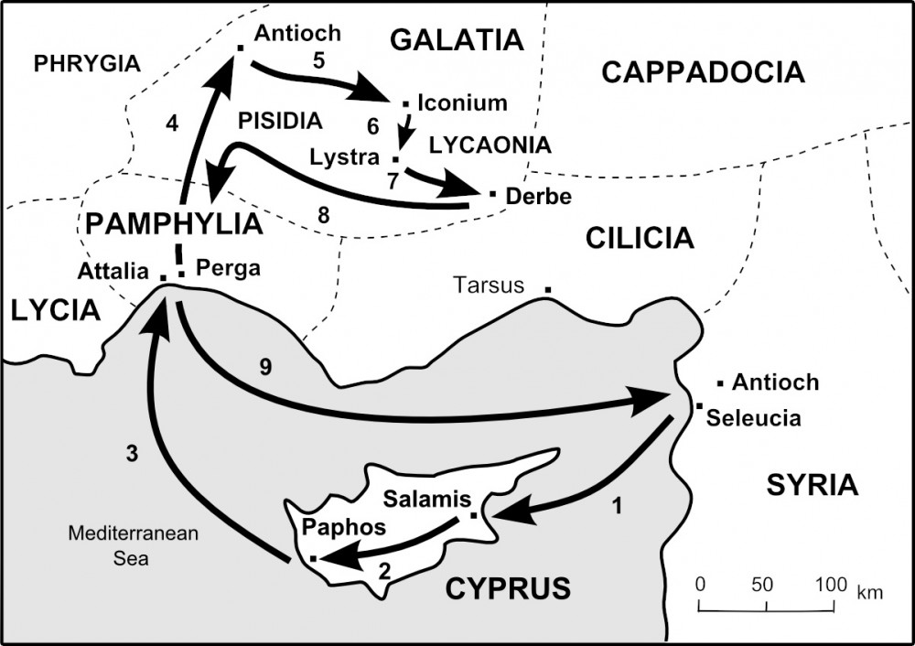
Paul’s second missionary journey | 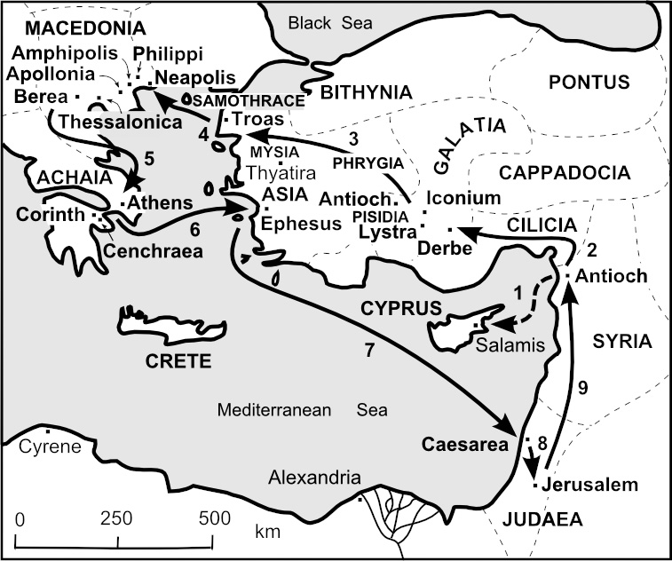
Paul’s third missionary journey | 