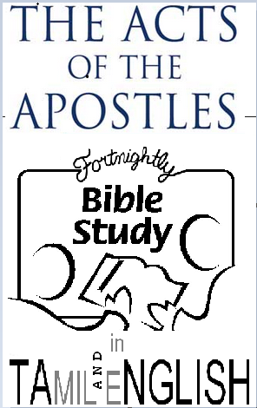
The riot in Ephesus

[Text: Acts 19:11-41]

Act 19:11-20.
How some in the Ephesian church had not genuinely repented until they heard about the incident with the seven sons of Sceva. But now, as proof of their confession, they brought their magic books and burned them.

Acts 19:21-27 The spark that lit the fire
Paul’s travel plan is mentioned in 19:21, but Luke has more to say about Paul’s effect on the Ephesian society and religion and the riot that ensued. Paul may have been referring to this riot when he told the Corinthians how he had fought with wild beasts at Ephesus (1 Cor. 15:32). What was Paul’s crime? He had preaching the gospel.
The riot was in retaliation to the impact of the lives of the believers. Not only were they changed, but the gospel had changed the life of the city’s commerce, education, art, and relaxation. Those believers not just talked the talk, but they walked the walk, unlike those mentioned in Mat 7:21-23.
Evidence of true repentance is a commitment to holiness. In the Old Testament God had called Israel to be holy and separate from the neighbouring nations, primarily so they would not be led into sin. Romans 12:2 We are constantly and unconsciously being pressed and moulded into the image of the world. When you follow Jesus, it shows in your lifestyle, conversation, the choices that you make, and in the events you no longer participate in. Psalm 1: 1. The blessed man does not go with the flow.

Acts 19:21-27 Why people oppose preaching of the gospel
People came to the Temple of Artemis in Ephesus, as it was one of the Seven Wonders of the World, and also because the goddess was perceived to grant the prayers of the childless. The temple of Artemis also served as a bank also and people from all over the world deposited funds there. The annual festival in honour of Artemis drew a great deal of business to the area, including buyers of these small statues.
That bottom line in the speech of Demetrius the silversmith was that the entire economy would be affected. He made his speech in a way that did not sound selfserving. Instead he suggested that perhaps even the great goddess, whom the whole world worshiped, would be dethroned from her magnificence!
This was all these craftsmen needed to hear. Paul was threatening their livelihood, their trade, and their pride. The speech of Demetrius in Acts 19:25-27 is similar to the accusations made in Philippi (Acts 16:20-21), Thessalonica (Acts 17:6-7), and Corinth (18:13).
But there is a bigger reason behind the riot than even Demetrius. The devil is opposed to God and His Messiah (Eph. 6:12). (2 Cor. 4:3-4). Demetrius and the silversmiths probably had heard of and seen evidence of the many miracles that God had been doing through Paul in Ephesus but they did not stop to check if Paul and the believers could be preaching the truth. Sin and Satan blind people so that they can’t see how irrational they are. Even a child would agree that “gods made with hands are no gods at all.”
People oppose the gospel because it confronts their sinful life styles. (Acts 19:20). Whenever the church repents of her sins and the word of the Lord prevails, and then Satan launches an attack.

Acts 19:28-41 God’s providential protection
Only by God’s gracious providence were Gaius and Aristarchus spared from being killed. On earlier occasions, Paul was stoned and beaten. Here, he was spared. But whatever happens, we can always know that God’s providential care and direction are ours. Satan is on a leash, and can only go as far as God lets him.
In the riot in Ephesus, we see God’s providential protection of Paul and the other believers, using non-Christian friends of Paul, the Asiarchs (who were from the noblest and wealthiest families in the province of Asia, who served for a year in the imperial cult of emperor worship. God finally protected Paul and the Ephesian Church through the wise words of the town clerk, who is comparable to the mayor. God provided protection for Paul and for the preaching of the gospel through pagan men who were in positions of political power. The sovereignty of God is once again evident.

